

Oshwal college in collaboration with University of Greenwich
School of Computing and Mathematical Sciences
BSc hons in Computing
Comp-1770 Professional Project Management

Word count;
Names; Alizma Vishnani, Krushi Modi, Tidiane Souare, Denver Soi
Academic year 24/25

Table of Contents
SCOPE OF THE PROJECT 2
SMART objectives 3
Stakeholders 5
RACI CHART 6
Requirement Prioritised Listing (RPL) 8
Requirements identification 8
Functional Requirements 8
Non-functional requirements 9
MoSCoW prioritization 10
Delivery plan 12
Work Breakdown structure (WBS) 12
Gantt Chart 14
Project risk 16
SWOT Analysis 16
Risk Register 17
Costing 19
PART 2 INDIVIDUAL 21
References 22

SCOPE OF THE PROJECT
The scope of the project involves the planning, design, development and delivering of a comprehensive web-based management system for LHC. The scope mainly includes activities required in creating a digital platform that meets user and business needs, as identified by LHC. Some of the key functionalities include:
- Customers will be able to view and book fitness appointments online.
- A secure merchandise online store through which one can get customer incentive features such as promotions and bundles of LHC products.
- A digital system for managing employee training and developing.
- Automated waiting list and cancellation management features.
- Implementation of a data protection and privacy compliant with the GDPR( including encryption, consent tracking and multi-factor authentication)

The project does not include the following:
- The development of a mobile application
- Physical infrastructure changes within the gym facility
- Ongoing system maintenance after deployment

SMART objectives

Objective | Specific | Measurable | Achievable | Relevant | Time-bound
Implement class booking system | Enable online booking for classes, trainers, and physiotherapy | 100% of available spots bookable online | Yes, with current team resources | Aligns with customer satisfaction goal | MVP within 8 weeks
Online merchandise store | Users can purchase merchandise online | 100% transactions processed securely | Yes, via standard e-commerce platform | Supports revenue growth | MVP within 8 weeks
Employee training module | Staff can register and track progress | 100% of training registrations handled online | Yes, integration with HR data | Supports internal operations | MVP within 8 weeks
Ensure GDPR compliance | Secure storage and encryption of sensitive data | Zero GDPR violations | Yes, follow GDPR best practices | Required by law | Full system deployment

Stakeholders

Name | Role
Anna Roberts | Project sponsor (approves designs/testing)
Satya Shah | - Business lead (finds revenue and customer experience goals)
Amina Okafor | - finance stakeholder (oversees e-commerce transactions promotions)
Guy Martin | - HR stakeholder (manages employee training and data compliance)
PPL project manager | - contractor lead (oversees development,timeline and budget)
System Analyst | - requirements leads (converts business needs to technical specs)
Developers | Coders (build,integrate and secure the system)
Database admin | Data security (manages databases and GDPR compliance)
Testers | - Quality control (test and validate the system)
LHC customers | - End users (use the system for bookings and purchases)
LHC employees | - internal users (manage operations and training)

RACI CHART
The RACI chart was created based on the newly created service process flow chart. The purpose of the RACI chart is to define in more detail what is expected to happen by the stakeholders in each process face. (Mattila, 2024)

PROJECT  ACTIVITY | Anna  Roberts  (Sponsor) | Satya  Shah  (BDM) | Amina  Okafor  (Finance) | Guy Martin  (HR) | PPL  Project Manager | System analyst | Developer | Database admin | Testers
1.Requirement Gathering & Analysis | A | C | C | C | R | R
2. System Design | A | C | C | C | R | R | C | C
3.MVP Development | I | I | I | I | A | C | R | R
4.Full System Development | I | I | I | I | A | C | R | R
5. Testing & Quality Assurance | I | I | I | I | A | C | C | C | R
6.Development & User training | A | C | I | C | R | C | R
7.Data protection & GDPR  Compliance | A | I | I | C | R | C |  | R
8.Project Management & Progress reporting | I | I | I | I | A | C

Key:
R = Responsible (does the work)
A = Accountable (final authority, signs off)
C = Consulted (provides input/expertise)
I = Informed (kept updated on progress)

ASSUMPTIONS FOR RACI CHART:
- The VP for IT systems, is the overall project sponsor and final decision maker on system design.
- The PPL team(Project Manager, Analyst Developers, Testers) acts as the delivery team.
- Critical issues are escalated to Anna Roberts for resolution.
- Full system completed in 6 months following iterative design and testing cycles.
- Guy Martin and Anna Roberts ensure compliance with GDPR and Internal data policies.

Requirement Prioritised Listing (RPL)

Requirements identification

Functional Requirements
Functional Requirement | Prioritization | Assumption/Details
Class booking | Must-Have | This allows customers to view available classes, book their convenient timings, join the waiting list for required sessions. Allows calendar blocking/integration.
Merchandise store | Must-Have | Customers are able to browse, add to cart and purchase LHC merchandise online.
Discounts and packages | Could-have | Discounts are applied automatically according to users' usability/loyalty.
User authentication | Must-have | Secure logins,multifactor authentications and account management for all users(staff and customers).
Admin dashboard | Must-have | Overall access given to admins to track the systems bookings and manage all users.
Employee training management | Must-have | Allows staff to register for programs, generate reports for HR while tracking progress.
Notifications and alerts | Should-have | Confirmation for bookings,cancellations or promotions to be sent to all users.
Secure payment for classes, training and merchandise | Must-have | Transaction integration for secure payments for classes, training and merchandise.

Non-functional requirements

Non-Functional Requirement | Prioritization | Assumption/Details
Usability | Must-have | The interface should be intuitive for users with varying technical abilities.
Security and compliance | Must-have | Full GDPR compliance and encryption of sensitive data
Performance | Should-have | Fast and efficient for handling multiple bookings
Scalability | Could-have | Should support future expansion
Reliability | Should-have | Minimal downtime
Accessibility | Should-have | Meets web accessibility standards

MoSCoW prioritization

Priority | Requirement | Reasons
M – Must Have | Online class booking & automatic waiting list management | Core business problem being solved
 | Online booking for personal trainers and physiotherapists | Critical to replace manual system
 | Secure online payment integration | Essential for transactions
 | Merchandise e-commerce store | Strategic business expansion goal
 | GDPR-compliant data storage and encryption | Legal requirement
 | Multi-factor authentication and user consent management | Security and compliance
 | Employee training registration and tracking system | Required by HR for internal use
 | Admin dashboard for managing bookings, users, and products | Core system control
 | Automated notifications for bookings, cancellations, and waiting lists | Improves efficiency and user experience
S – Should Have | Discount bundles and promotional packages | Enhances customer engagement
 | Performance analytics and financial reporting | Supports business decisions
 | Accessibility features (WCAG compliance) | Improves usability and inclusivity
C – Could Have | Customer loyalty or reward program | Adds value but not critical to launch
 | Integration with fitness tracking apps or wearables | Future enhancement
 | Social media integration for sharing achievements or promotions | Marketing improvement
W – Won’t Have (for now) | Mobile app version (Phase 2 feature) | Out of current scope due to budget and timeline
 | Virtual classes or live-streaming | Future phase after system stabilization
 | AI-driven personal trainer recommendations | Long-term innovation goal

Delivery plan
Project title: Lifestyle Health Centre (LHC) - Web-Based Management System
Timeframe- 6 months (24 weeks)
MVP deadline- 8 weeks

Work Breakdown structure (WBS)
A robust WBS hierarchically and faithfully reflects all project tasks and work packages so that projects are easier to manage. If done properly, the WBS also allows meeting the project objectives while delivering the project on time, on budget, and with the required quality according to (Cerezo-Narváez, 2020)
WBS Level | Task / Deliverable | Description / Activities | MoSCoW Priority
1.0 | Project Initiation | Define goals, assign team roles, prepare documentation | Must
1.1 | Requirement Analysis | Review user and system requirements | Must
1.2 | Feasibility & Risk Assessment | Identify risks, compliance, and technical feasibility | Must
2.0 | System Design | Design user interfaces and architecture | Must
2.1 | UI/UX Design | Create layouts for booking system, store, dashboard | Must
2.2 | Database Design | Define data models for bookings, users, inventory | Must
2.3 | Security Design | Plan encryption, GDPR compliance, and authentication | Must
3.0 | Core Development (Must Haves) | Build main system components | Must
3.1 | Class Booking Module | Develop booking and scheduling functions | Must
3.2 | Secure Payment Integration | Add payment gateway for classes & merchandise | Must
3.3 | Merchandise Store | Build product listing, cart, and checkout | Must
3.4 | Employee Training Management | Allow staff training registration & tracking | Must
3.5 | GDPR Compliance Implementation | Apply data protection and encryption | Must
4.0 | Additional Development (Should Haves) | Extra features to enhance experience | Should
4.1 | Discounts & Packages | Add promotional offers and loyalty bundles | Should
4.2 | Accessibility Features | WCAG 2.1 compliance (screen reader, contrast) | Should
4.3 | Performance Analytics | Basic reporting and data visualization | Should
5.0 | Optional Enhancements (Could Haves) | Future improvement ideas | Could
5.1 | Customer Loyalty Feature | Track and reward repeat users | Could
5.2 | Social Media Integration | Share achievements/promotions | Could
6.0 | Testing and QA | Test for functionality, security, and usability | Must
6.1 | Unit and Integration Testing | Validate each component | Must
6.2 | Usability & Accessibility Testing | User testing on various devices | Should
6.3 | Performance & Load Testing | Ensure fast response under load | Should
7.0 | Deployment & Review | Deploy, review, and finalize documentation | Must
7.1 | Deployment to Production | Launch system for users | Must
7.2 | User Training & Documentation | Staff and admin manuals | Must
7.3 | Final Review & Maintenance Plan | Handover and support strategy | Must

Gantt Chart
Gantt charts illustrate the start and finish dates for both the smallest tasks in a project and higher-level tasks that encompass multiple terminal elements. (Wadhwa, 2024)
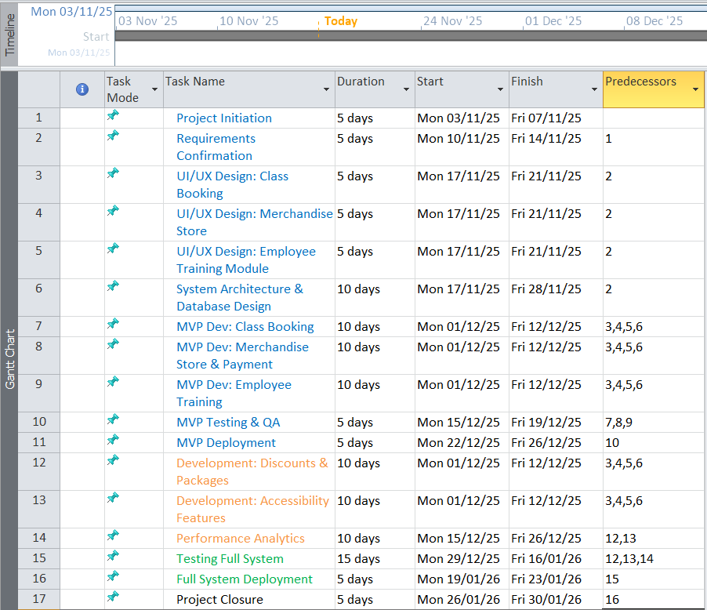
Blue- Must-Have (MVP) tasks
Orange- Should-Have tasks
Green- Full System tasks
Grey- Closure
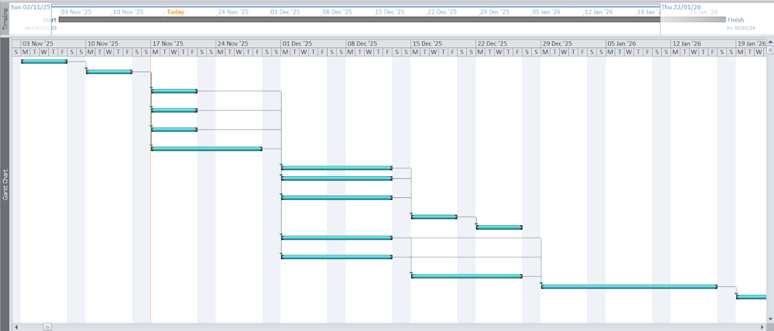

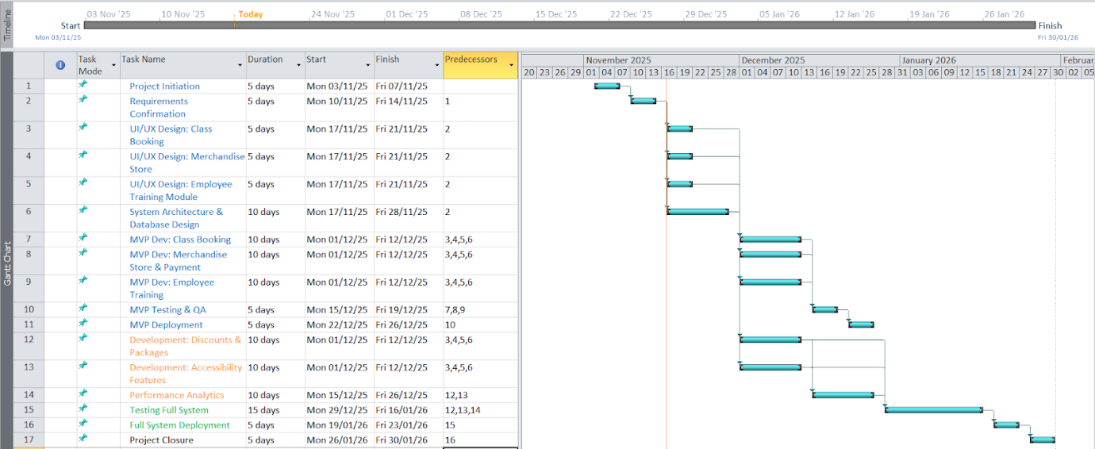

Project risk
Project risk management is the process of identifying, analysing and responding to any risk that arises over the life cycle of the project to help the project remain on track and meet its goal. Risk management isn’t reactive only; it should be part of the planning process to figure out the risk that might happen in the project and how to control that risk if it in fact occurs according to (Schwartz, 2025)

SWOT Analysis
SWOT is a tool used for strategic planning and strategic management in organizations. It can be used effectively to build organizational strategy and competitive strategy (C.R & K.B, 2023)
Strength | Weakness | Opportunity | Threat
Clear business objective | Inhouse technical skills might be limited LHC depends on PPL for development | Cloud-Based deployment opportunity, the system will allow scalability and remote maintenance. | Privacy Risk - any breach could cause financial and social damage to both PPL’S and LHC
Strong stakeholder commitment | Budget Constraints | Emerging market for fitness Technology | Downtime issue unforeseen bugs or server crash could delay release
Scalable infrastructure  ure | Complex integration of the system | Upselling future enhancement for more advanced features | Competition from off the shelf products produce ready made product that pose a threat (Seacord et al, 1999)
Used agile development approach | Maintenance Responsibility | Adoption of Secure practices and architecture implementation of GDPR procedures. | Third party dependency risk depending on third party features like APIs could cause disruptions if they fail.

Risk Register
A risk register, or risk log, is a risk management tool used to identify potential risks that could affect the execution of a project plan. (Landau, 2023)
 | Risk description | Category | Triggers | Risk Mitigation | Possibility | Impact | Risk score | Detection  (easy=1 hard =5) | Risk priority number
R1 | Inadequate backup | Technical | Due to insufficient policy or accident it may cause loss of backup* | Do automated scheduled backup and store them in different locations | Low(2) | High(5) | 10 | 4 | 10
R2 | Budget over run may be due to hosting cost | Financial | Due to serve load charges may increase or decrease going over the estimated budget | Avoid unnecessary premium tools and over budget just in case there's an uptick in customer | Medium(3) | Medium (3) | 9 | 3 | 9
R3 | System downtime may be caused by server failure | Technical | Maybe caused by bugs, hosting issue or system overloading | use a reliable server provider and implement server monitoring devices | Low (2) | High(5) | 10 | 4 | 10
R4 | Cyber threat | Security | Cyber Attackers be it insider or threats from outside | Do regular system update and patches and security audits and training | Medium(3) | High (5) | 15 | 5 | 15
R5 | Staff and user unfamiliarity | Organization | Resistance to change or lack of staff training | Do regular staff training and and gather feed back | High (5) | Medium (3) | 12 | 2 | 15
R6

Costing
Months
WBS Items | 1 | 2 | 3 | 4 | 5 | 6 | TOTAL
1.Project Management
1.1 Project manager | £7000 | £3000 | £3000 | £3000 | £3000 | £2000 | £21000
1.2 Development team | £5000 | £5000 | £5000 | £2000 | £2000 | £1000 | £20000
2. System development
2.1 Backend server | £10000 | £25000 | £20000 | £15000 | £7000 | £0 | £77000
2.2 frontend server | £8000 | £18000 | £15000 | £12000 | £5000 | £0 | £58000
2.3 database design | £10000 | £12000 | £10000 | £0 | £0 | £0 | £32000
3. Software and services
3.1 hosting and domain | £7000 | £0 | £0 | £0 | £0 | £0 | £7000
3.2 licensed software | £8000 | £0 | £5000 | £0 | £0 | £0 | £13000
4. testing
4.1 system testing | £0 | £0 | £0 | £8000 | £7000 | £0 | £15000
4.2 User acceptance testing | £0 | £0 | £0 | £0 | £0 | £12000 | £12000
5. Training and support
5.1 training cost | £0 | £0 | £0 | £0 | £6000 | £4000 | £10000
5.2 travel cost | £0 | £0 | £0 | £0 | £0 | £5000 | £5000
5.3 project team members | £0 | £0 | £0 | £5000 | £5000 | £5000 | £15000
6. Reserves | £0 | £0 | £2000 | £10000 | £3000 | £8000 | £23000
MONTHLY TOTAL | £55000 | £65000 | £60000 | £55000 | £40000 | £25000 | £300,000

PART 2 INDIVIDUAL

Team performance
Student Name | Role | Contribution(100%) | Student Signature
Tidiane Souare |  | 100% | TS
Alizma Vishnani |  | 100% | AV
Krushi Modi |  | 100% | KM
Denver Soi |  | 100% | DS

References
C.R, S. K. & K.B, P., 2023. SWOT ANALYSIS.
Cerezo-Narváez, A., 2020. Integration of Cost and Work Breakdown Structures in the Management of Construction Projects.
Landau, P., 2023. What Is a Risk Register & How to Create One.
Mattila, S., 2024. Improving Service Process Flow Chart.
Schwartz, B., 2025. The Risk Management Process in Project Management.
Wadhwa, K., 2024. THE ROLE OF GANTT CHART IN PROJECT.

